Γ2 - My daily routine

We talk about our daily routine.
Content
The mascot tells the children what he/she does in the morning, in the evening and at night. Then, children play in the school yard and learn to tell the time.
Language objectives
- To learn words or phrases related to daily routine
- To repeat words/phrases, such as breakfast, lunch, dinner, in the morning, in the afternoon, in the evening, at night
- To learn to ask ‘What’s the time?’ and answer ‘It’s 7 o’clock’
- To develop oral comprehension and oral production skills
- To learn to pronounce and read the letter O/o (see instructions)

Pedagogical goals
- To become familiar with the concept of daily routine
- To learn to focus on what they listen to in order to put certain activities into a chronological order
- To understand the concept of time and particularly the passing of time
Materials:
- The mascot
- Pictures (B_Γ02_C01, B_Γ02_C02, B_Γ02_C03, B_Γ02_C04, B_Γ02_C05, B_Γ02_C06, B_Γ02_C07, B_Γ02_C08, B_Γ02_C09)
- Blu tack
Equipment:
- CD player and/or P/C
ABC Worksheets: Β_Γ02_W01, Β_Γ02_W02
- Picture for the particular letter (O_C)
- CD/ Songs for the specific letter (O_M)
- ABC Worksheet (O_W)
Suggested time: 2 teaching hours

Suggested procedure
Step 1 We begin our lesson holding the mascot and telling children that Mary wants to talk to them about her daily routine. We set a clock to 7.00 and say: ‘I wake up at 7 o’clock in the morning’ and we stick the relevant picture with blu tack on the board (B_Γ02_C01). Then, we set the clock to 8.00 and we say: ‘I go to school at 8 o’clock in the morning’ – and we stick the relevant picture next to the previous one (B_Γ02_C02). We continue the procedure changing the time on the clock, sticking the pictures on the board, saying: ‘I do Μaths at school at 10 o’clock in the morning’ (B_Γ02_C03), ‘I go back home at 2 o’clock in the afternoon’ (B_Γ02_C04), ‘I have lunch at 3 o’ clock in the afternoon’ (B_Γ02_C05), ‘I do my homework at 4 o’clock in the afternoon’ (B_Γ02_C06), ‘I play with my friends in the garden at 6 o’clock in the afternoon’ (B_Γ02_C07), ‘I have a shower at 8 o’clock in the evening’ (B_Γ02_C08), ‘I go to bed at 9 o’clock at night’ (B_Γ02_C09).
Step 2 Now the mascot wants to see if children can remember her daily routine and asks them questions pointing at the relevant card: ‘I do Μaths at school. What’s the time?’ ‘I have lunch. What’s the time?’, etc.
Step 3 We take the pictures off the board and give students worksheet 1 (Β_Γ02_W01). We ask them to remember the mascot’s daily routine, put the pictures given in the correct order and number them. When they have finished, we ask them to swap their worksheets with the student sitting next to them and check each other’s answers. We repeat the mascot’s activities to facilitate the checking process and finally we encourage children to colour the pictures of their worksheet, if they wish to.
Step 4 Then, we give students worksheet 2, (Β_Γ02_W02) and ask them to read with us what is written in the circles i.e. In the morning, In the afternoon, In the evening, At night. We explain that they will have to match the mascot’s activities with the correct time. Then, we check the answers as a group.
Step 5 We play the game ‘What’s the time, Mr Wolf?” in the school yard (children are familiar with the game from last year). We ask a student to be the seeker and pretend to be the wolf, while the rest of the students stand in a row (next to each other, 10-15 metres away). Students ask the wolf/seeker: ‘What’s the time, Mr Wolf?’ and the wolf may answer: ‘It’s three o’clock’. Then, children make as many steps towards him/her as the hours the wolf has told them. The game continues until the wolf has understood that children are very close to him and answers: ‘It’s lunch/dinner time!’. Then, he starts chasing the children who try to run away. Whoever gets caught will be the wolf/seeker in the next round.

Educational Material
(Click on the archives to download the material)

Pictures
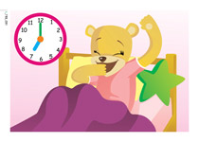 |  | 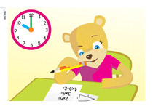 | 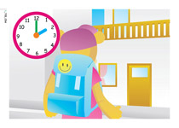
B_Γ02_C01 | B_Γ02_C02 | B_Γ02_C03 | B_Γ02_C04

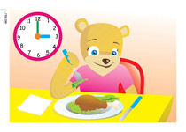 | 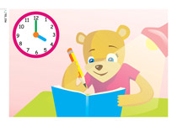 | 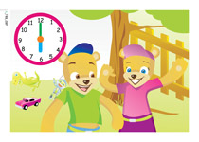
B_Γ02_C05 | B_Γ02_C06 | B_Γ02_C07 | B_Γ02_C08

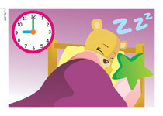
B_Γ02_C09

Worksheet
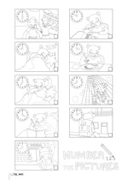 | 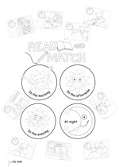
Β_Γ02_W01 | Β_Γ02_W02

ABC
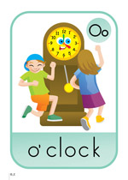
O_C

ABC Worksheet
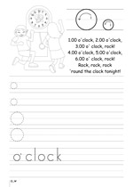
O_W

Audio material
- O_M: Letter O
Lyrics
O,o
1.00 o’clock, 2.00 o’clock, 3.00 o’ clock, rock
4.00 o’clock, 5.00 o’clock, 6.00 o’ clock, rock
Rock, rock, rock
‘round the clock tonight!

